**Structure and diversity of bacterial and Archaeal communities in glacial cryoconite balls from Foxfonna glacier at Svalbard**

The cryosphere represents some of the most challenging conditions for life on Earth. Microorganisms are found to be well adapted to life within the cryosphere, and they play a crucial role in the cycling of nutrients within glacial environments (Figure1).

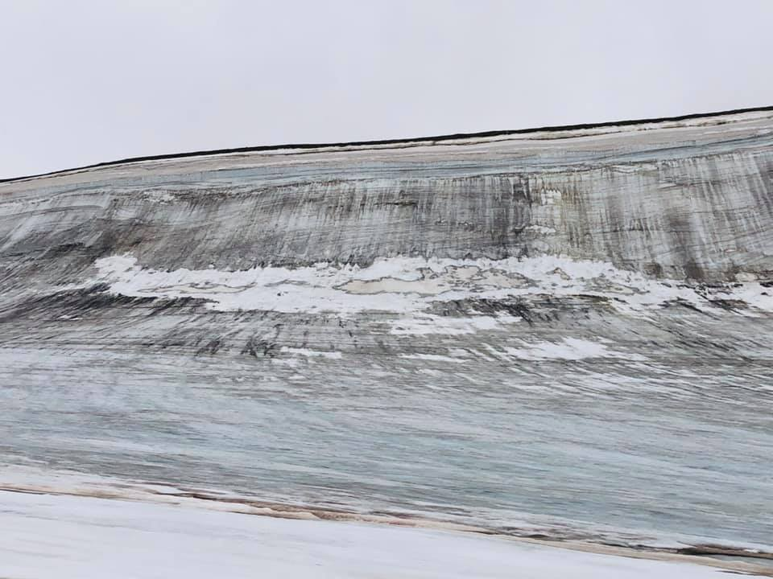Figure 1

Cryoconite holes are found on glacial surfaces and contain granular sediments composed of both mineral and biological material, containing dark granular material (cryoconite). Due to its dark color, cryoconites efficiently absorbs solar radiation and this creates circular holes into the glacier ice surface. These holes can be from cm to meter in diameter and up to 0,5m deep (Figure 2a). Despite the fact that cryoconites have long been recognized as important glaciological and biological phenomenon, cryoconite remains relatively poorly understood.

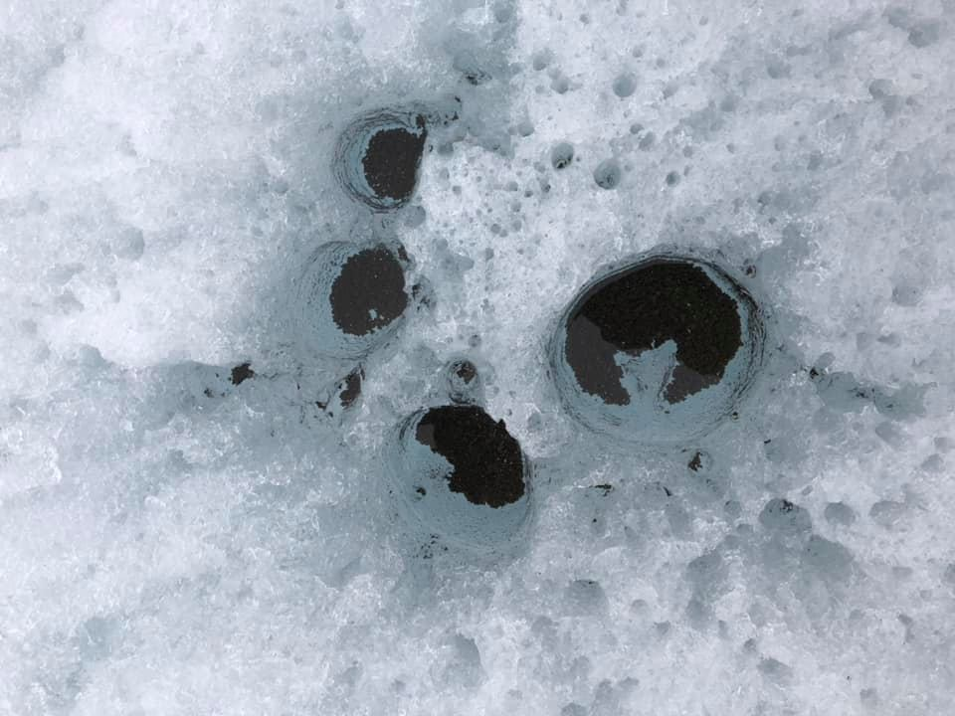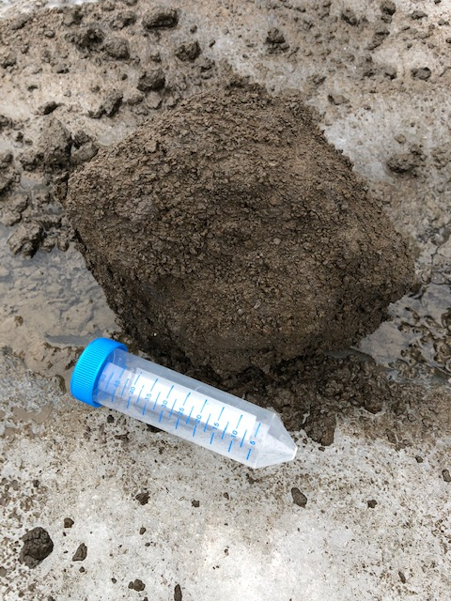

Figure 2a Figure 2b

This summer, cryoconite balls of the size 10 cm in diameter was collected from Foxfonna (Figure 2b). Previous studied of cryoconite balls have shown that a network of cyanobacteria holds the balls together. Cyanobacteria are autotrophic primary producers and use the sunlight to fix CO2. The cryoconite structures are aerobic around the outer rim but appears to be anaerobic in the inner part of the structures, this can be seen by a more red color at the outer part of the balls (oxidized iron) and darker brown/black in its interior (sulphur and methane). There are indications that there are iron oxidisers localized on the outer micoaerophilic zones of the cryoconites, and further indications that there are methanogens producing methane inside these structures. In order to better understand how these important ecological niches are composed and structured on the top of the glacier, more detailed studies are needed on the microbial community composition.

Aims:

The aims of this proposed project are:

1) Describe the microbial community of Bacteria and Archea in the cryoconites by using Scanning Electron microscopy analyses

2) Identify microbes involved in the carbon cycle by targeting functional genes for methane oxidation pmoA and methane production mcrA

3) Set up enrichment cultures

Working plan:

Sample material will be collected and processed for Scanning Electron Microscopy analysis. DNA will also be extracted from the samples, and DNA used as target for specific PCR primers and various media for enrichments will be tested

Tutor:

Lise Øvreås

Research group:

Marine microbiology