THIS FREEZER CAN CONTAIN DRY ICE

BE AWARE OF HARMFULL CO2-GASS

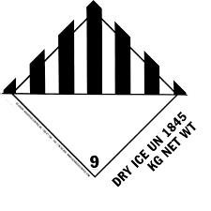

BIO Beredskapsvakt, TLF. 453 92 771

BIO Emergency guard, TLF. 453 92 771